

## User Generated Functions

Pre #1: What is the syntax noted before #1 for how functions work?

| def function_name (argument1, argument2):  # What the function will do when it is called |
| --- |

1. Answer the following questions after reviewing the code in the trinket for #1:

| Letter | Question | Your Answer |
| --- | --- | --- |
| a | What is the function name? | def check_guess (guess): |
| b | How many arguments is it taking? | 1, a guess |
| c | How many different times is this function called? | The function is called three times, after each time a user makes a guess. |
| d | How does the function shorten the code? | The function has nine lines of code. Calling the function takes up one line of code. If there was no function, then each function call would be replaced with 9 lines of code. This is an example of abstraction. |

Paraphrase what the random module function is and does:

| The random module function is a series that generates random numbers. |
| --- |

## Classes and Objects

2) What looks familiar in the code? What is new?

| Familiar | New |
| --- | --- |
| List them here:   * The variable post_id is an integer. * There are 5 functions in this code. | List them here:   * The line from datetime import datetime * The class keyword * The self keyword * The __init__ function * The return keyword |

Answer the following in your own words,

| What does *class Post* mean or do? | Prepares the file to be a class |
| --- | --- |
| What does *post_id=0*, do or mean? | A class variable means that all posts will have a post_id. |
| Define methods: | A function that is a member of a class |
| Explain what the following methods do: |  |
| ___init___ | Initializes a post object; method must exist in a python class |
| ___str___ | Returns a string with all info of the post |
| set_message(msg) | Sets the variable message to a string msg |
| get_user_name(usr) | Returns a username associated with a post |
| get_post_id | Returns the id number of a post |
| Explain what *self* does or mean | Self represents the Post object itself |

Tell me which lines of code the methods from above are used in the code for Post.py:

| code/method | line |
| --- | --- |
| ___init___ | 12 |
| ___str___ | 20 |
| set_message(msg) | 24 |
| get_user_name(usr) | 28 |
| get_post_id | 32 |

## Object Oriented Programming (OOP)

Define the following terms:

| Object-oriented programming | Style of programming language that focuses on creating reusable patterns of code |
| --- | --- |
| class | A template for creating objects |
| object | An instance of a class |

Here is an interest way to look at classes and objects:

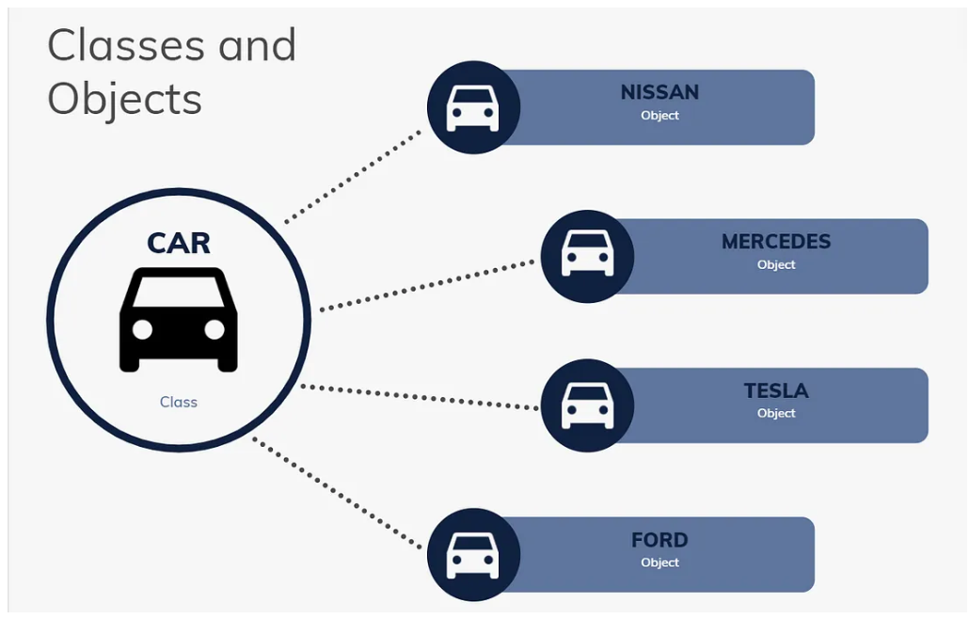

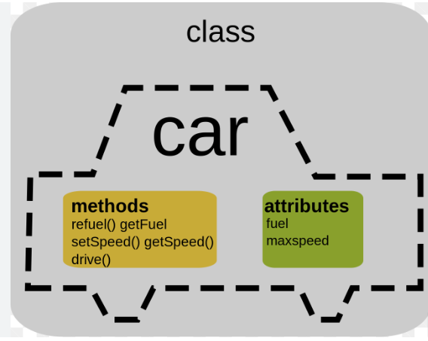

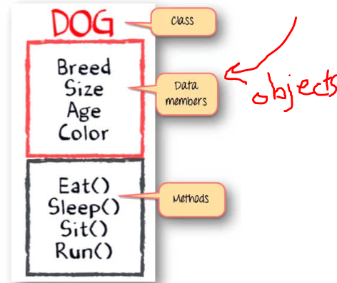

5) Create two more posts with different users and messages, run your code. Take a screen shot of it and put it here: Post 2, include your name and something about the weather today. Post 3, include your name and something about your favorite past time/hobby.

|  |
| --- |

6) no need to transfer this to VS Code or anything right now. Just leave it in your cache of your computer/browser.

7-9) Lets do this on VSCode. I find it just works better. Click the hamburger at the top left of the Trinket on myplw. Click Download. This will zip main.py, post.py and skeleton.py into on ZIPPED Folder in your DOWNLOADS FOLDER on the PC/desktop. Go to your Downloads Folder on the computer, right click, click Extract All, find your desired folder and hit extract. I am putting mine into a 3.2 folder inside of my CSE Folder on my desk top.

Generate code just as MYPLTW says to in order to prompt the user with commands available to them and their input. At the end of #9 put a # comment and your name. Give me a screenshot of all of that code, here:

|  |
| --- |

10. (new) Think about the actions that the code needs to take in order to make this “post” or go “live” on social media. Essentially, I am asking you to think in pseudocode. Here is how it breaks down in my head:

1. We need to compare the user_input to something (if user_input = ‘new’)
2. If it is true, then we need the code to ask the user for a message to display, go ahead and give that message a name/variable like ‘message’
3. We next need to add the ‘message’ to the “social media site”, we know it as Post, like we did in number 3 of this activity. There are some arguments that will make this “message” or “Post” unique. Its username and its message.
4. We need to add (.append) this “post” to the list of all archived posts that was opened up at the beginning of the program